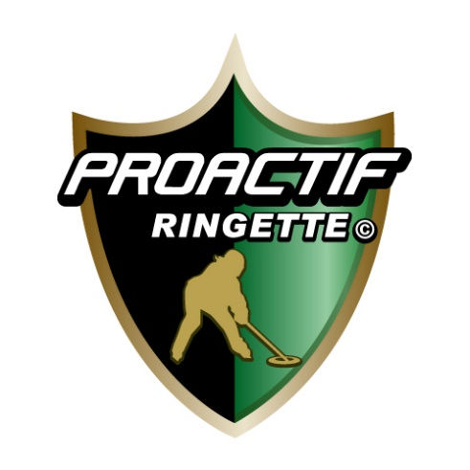

Operational Guide for Summer Programs 2020

As of June 9th (may be subject to change)

With all that is occurring with Covid-19, it is very important to our entire Atlantic Hockey Group team, which includes Proactif Ringette and Atlantic Jr Attack Academy, that we set out clear guidelines to assist our parents in preparing for our Summer programs. Below we hope we provide clear direction on how Summer camps will operate and what you can expect. We have prepared a formal operational plan for New Brunswick Public Health; however the information below will focus on the key components as it relates to our families. We would ask that all parents/guardians please read this entire page. We want to thank the Superior Propane Centre team in Moncton for their assistance in working together to come up with a detailed plan!

Safety Awareness

An important component of this summer will be ensuring that all program participants are aware of safety precautions to limit contact and limit potential spread of Covid-19. To that end, we would please ask that parents/guardians speak with their children prior to attending the camps about things such as limiting contact with others, covering mouth when coughing/sneezing, washing hands before coming to the rink, and not sharing water bottles with others. All staff will be trained on detailed safety procedures as set out in our operational plan.

Camp Times

Because of the need to provide physical distancing and adhering to limits on the number of players and parents that can be in the facility at a given time, camp times will be staggered. For example the first group for a camp would be at the rink from 8:30am to noon, then the 2nd group would arrive. This will differ from our regular format where camps would run for full days. Detailed schedules will be sent out prior to the camps to all families.

Arrival and Getting Ready

Camp participants will only be allowed to enter the Superior Propane Centre 15 minutes before their scheduled start times. With physical distancing restrictions in place - we would ask that only one adult/guardian per family be responsible for drop-off and pick-up for the duration of the camp. A screening tent will be setup outside the main entrance to the Superior Propane Centre.

Please note that no one with a mandatory 14-day self-quarantine order (as per NB government) will be permitted to enter the building. Additionally if participants have 2 or more of the symptons of Covid 19 (as set out by the New Brunswick Government) they will not be allowed to enter the facility.

Players should come to the rink dressed in their equipment, with the exception of skates, gloves, and helmet. There will be marked paths that players can follow. No dressing rooms are allowed to be used with Covid-19 restrictions, so players will be asked to put on skates and other equipment on benches set up in in the rinks. AHG staff will be in place to assist where required.

End of Day

Players will be required to leave 10 minutes after sessions are concluded. When the camp day is finished, we would ask that parents wait in their vehicles outside the facility and do not come into the building. While not mandatory, it is suggested that parents do their best to disinfect and clean equipment at the end of the day.

On-Ice Drills (Overview)

Certainly, with the focus on physical distancing and limiting contact most camps will have different on-ice drills and components than in previous years. Our staff is currently reviewing and updating all on-ice plans to ensure we meet safety guidelines in place. When on the ice player's will be required to have their own water bottles and each player will have their own separate area that will enable physical distancing from others.

Off Ice Sessions

The off ice sessions will be held on the non ice surface. At the end of the 2nd ice session, they will remove their ringette equipment and proceed to the non ice surface. They will need to have a T-shirt and Gym shorts and sneakers under their equipment as we do not have access to dressing rooms at this moment.

Parent Viewing

Unfortunately, because of the restrictions on the number of participants allowed into a rink at any given time, at this point, only 1 parent/guardian will be permitted to watch the sessions in the building. A second child is not allowed to accompany the parent. If regulations change this may be amended. Parent or guardian will need to wear a mask to enter the dressing area.

Communication

With the New Brunswick government requiring operators such as the Atlantic Hockey Group/ Proactif Ringette to have an operational plan - one component of that plan consists of "outbreak management". Certainly, we hope that this is an unlikely event to occur, however it is important that parents/guardians have their cell phones on while their child is at the camp. That is because if there is a suspected case AHG staff/NB Public Health will be required to contact the family immediately.

Thank You

We want to thank you in advance for your cooperation. Certainly, this year has been unprecedented in the hockey and ringette world, and for us in 30 years of business. By working together, we hope that we will be able to get our kids back on the ice and improving as players! Additionally, we want to thank the Superior Propane Centre and their team for their work in preparing detailed plans.

If you have any questions you can email us here: slapshot@nbnet.nb.ca

